ETICD: Final Project

4x4 bit multiplier

Group 3

By:

|  |  |
| --- | --- |
| Anders Dalsgaard Norlyk | au506145 |
| Mads Stockfisch | au520795 |
| Darryonna Armstrong | au583462 |
| Kelly Cuminsky | au583784 |
| Jonathan Brandt-Jensen | au526346 |

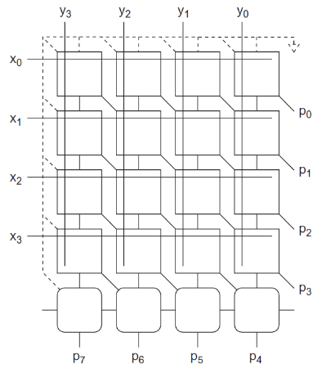

Figur 1: 4x4 bit multiplier design

# The task:

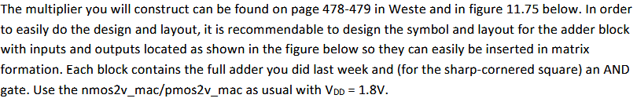

# Creating the Full adder schematic:

The full 4x4 bit multilpier is made out of several full adders but together in a 4 by 4 array like figure 1. So we started by making a single full adder in Candence .

Due to the size of the schematic, putting this full adder into a grid, would require a lot of extra work, so we instead made a symbol in Cadence representing the full adder:

## Analysing the Full adder:

After creating the symbol we made, a simple testbench to test, whether the logic table of our full adder matches the theoretic one, with a simple DC simulation.

# Creating the full 4x4 bit multiplier schematic:

After testing the Full adder we created a new schematic, where we set up the full 4x4 bit multiplier with our

## Analysing the 4x4 bit schematic:

# Creating the layout for the full adder:

## Doing the post-layout simulations for full adder: